Performance Fireplace Glass
www.PerformanceFireplaceGlass.com
^{Quick Reference – Cost Sheet}
(714) 997-2232

Small Fireplace  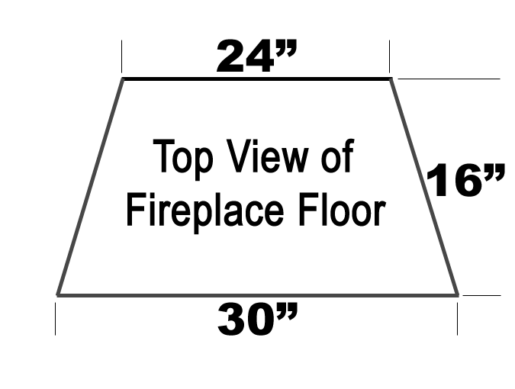 | Medium Fireplace  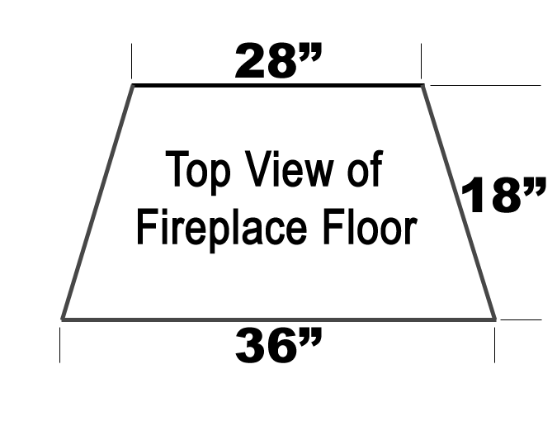 | Large Fireplace  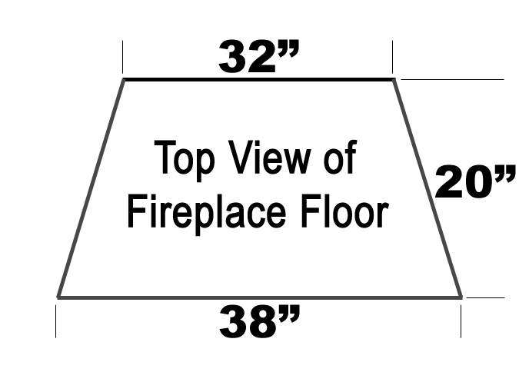
Option #1 – 3 Inch Fill  67 Lbs of ¼ Clear $288.10 | Option #1 – 3 Inch Fill  90 Lbs of ¼ Clear $387.00 | Option #1 – 3 Inch Fill  109 Lbs of ¼ Clear $468.70
Option #2 – 2 Inch Fill  45 Lbs of ¼ Clear $193.50 | Option #2 – 2 Inch Fill  60 Lbs of ¼ Clear $258.00 | Option #2 – 2 Inch Fill  73 Lbs of ¼ Clear $313.90
Option #3 – 2 Inch Fill  45 Lbs of ¼ Starfire $297.00 | Option #3 – 2 Inch Fill  60 Lbs of ¼ Starfire $396.00 | Option #3 – 2 Inch Fill  73 Lbs of ¼ Starfire $481.80

Small Fire Pit  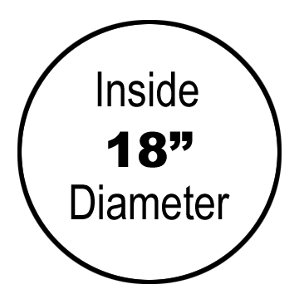 | Medium Fire Pit  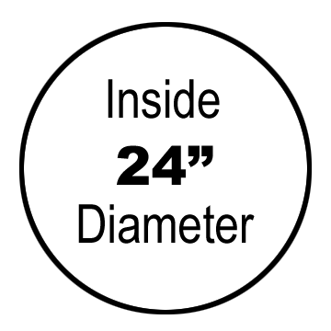 | Large Fire Pit  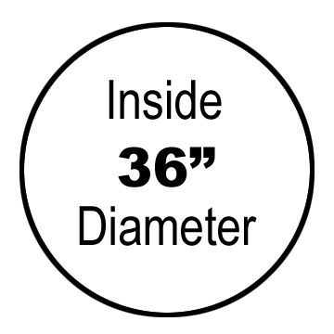
Option #1 – 2 Inch Fill  27 Lbs of ¼ Gray $124.20 | Option #1 – 2 Inch Fill  48 Lbs of ¼ Gray $220.80 | Option #1 – 2 Inch Fill  108Lbs of ¼ Gray $496.80
Option #2 – 1 ½ Inch Fill  20 Lbs of ¼ Gray $92.00 | Option #2 – 1 ½ Inch Fill  36 Lbs of ¼ Gray $165.60 | Option #2 – 1 ½ Inch Fill  81 Lbs of ¼ Gray $372.60
Option #3 – 1 Inch Fill  14 Lbs of ¼ Gray $64.40 | Option #3 – 1 Inch Fill  24 Lbs of ¼ Gray $110.40 | Option #3 – 1 Inch Fill  54 Lbs of ¼ Gray $248.40

